Sebastian Siqueiros
Module 4.2 Assignment
April 20, 2026

Flowchart 1

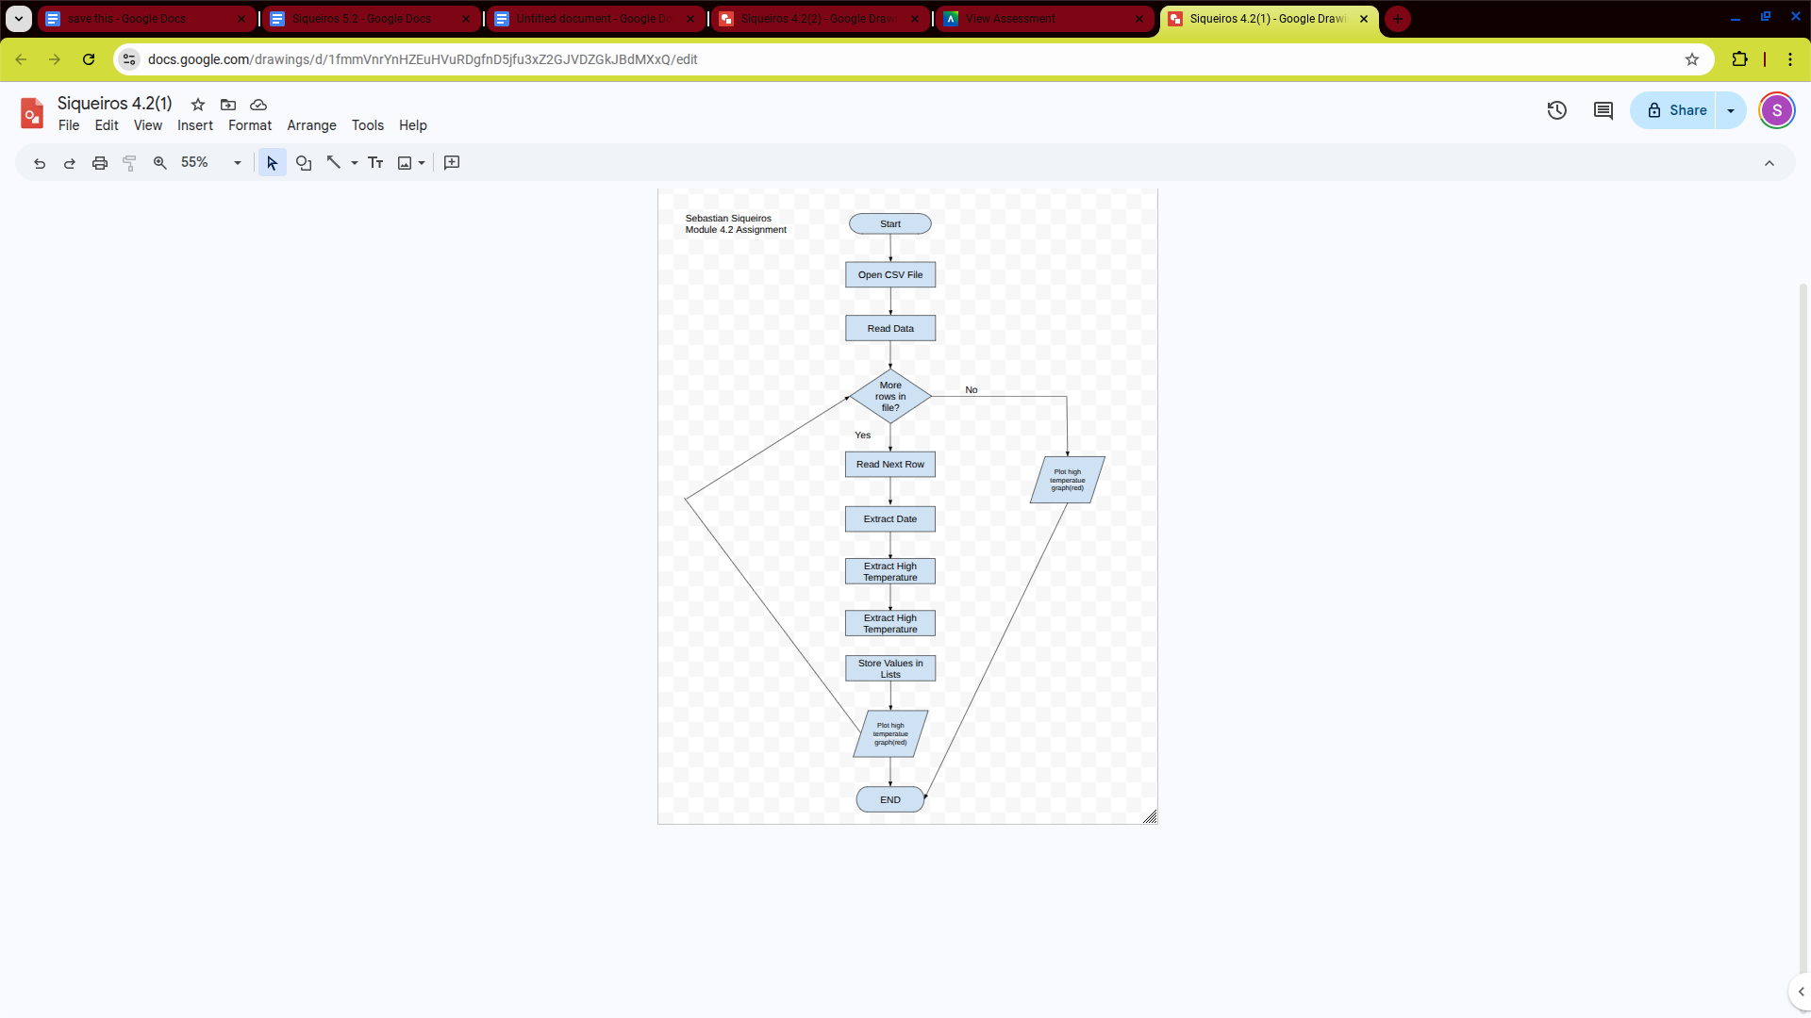

Flowchart 2
